**Q4. Binary Tree Nodes**

You are given a table, BST, containing two columns: N and P, where N represents the value of a node in Binary Tree, and P is the parent of N.

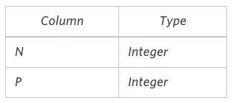

Write a query to find the node type of Binary Tree ordered by the value of the node. Output one of the following for each node:

Root: If node is root node.

Leaf: If node is leaf node.

Inner: If node is neither root nor leaf node.

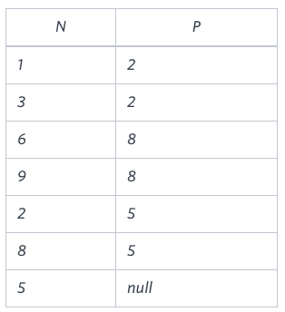**Sample Input**

**Sample Output**

1 Leaf

2 Inner

3 Leaf

5 Root

6 Leaf

8 Inner

9 Leaf

**Explanation**

The Binary Tree below illustrates the sample:

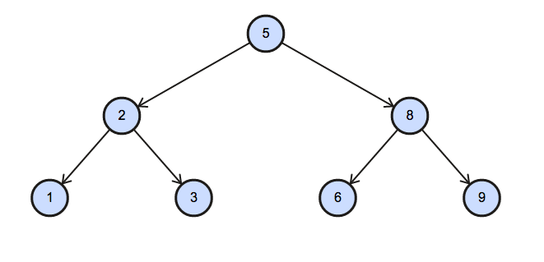

**Ans.**

SELECT N, CASE

WHEN P IS NULL THEN 'Root'

WHEN N IN (SELECT P FROM BST) THEN 'Inner'

ELSE 'Leaf' END AS NODE

FROM BST

ORDER BY N